**To view Images of the car you must consider the path in which this project is stored.  
To Change the Path go to line 120 of the CPP File.**

**For Instance, if the project folder named “Final Project” is stored in Drive D than change F to D in line 120.**

**See the image below.**

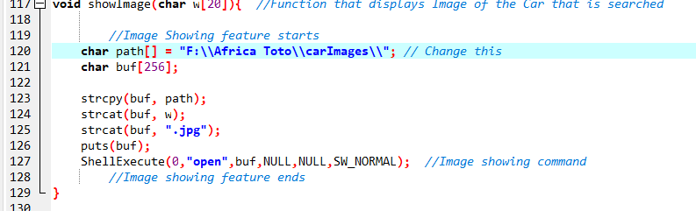

**As you enter car details, make sure you name the car same as your Image file stored in the CarImages Folder.  
For your ease, always begin the name of your car from an Uppercase Letter.**

**Have the image of the respective car stored in the carImages folder before entering details of the car.**

**Note: Store the folder “Final Project” in the Main drive i.e. C, D, E, F etc.**

**Note: While entering Brand Name please press the Space key once.**